**Assignment 22.1:**

Dataset link: [Census_data_analysis_using_spark](https://docs.google.com/document/d/1csLBlMiEXs_hXWV2Z8VpBlrj_R6RoDQLlZUnA0uBTCk/edit)

Due to limitation of 22 elements for a map function, we are taking only 22 columns from the dataset

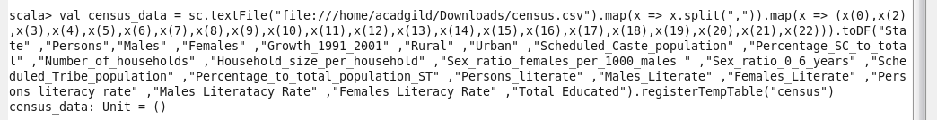

1. Find out the state wise population and order by state:

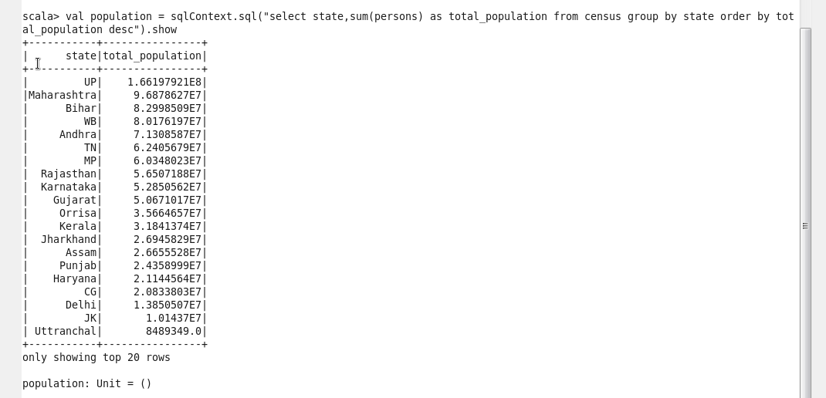

1. Find out the Growth Rate of Each State between 1991-2001

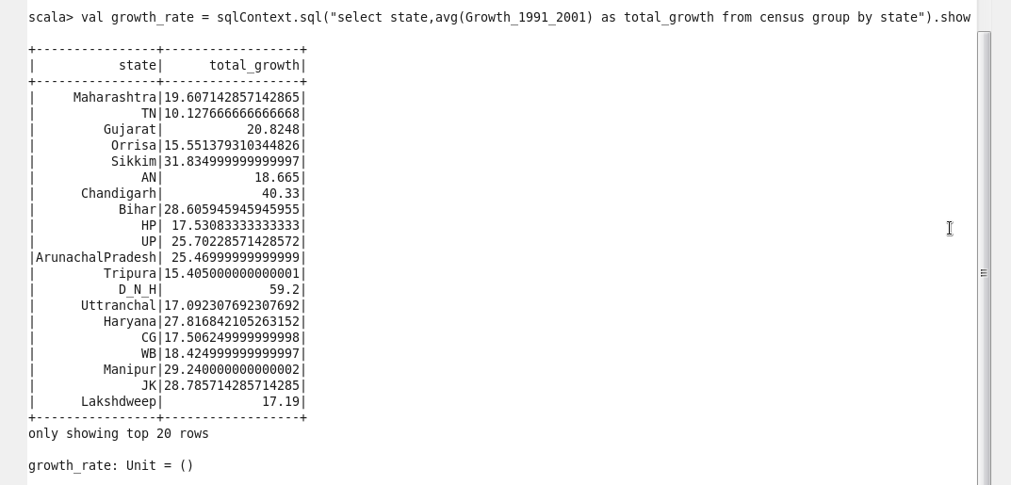

1. Find the literacy rate of each state:

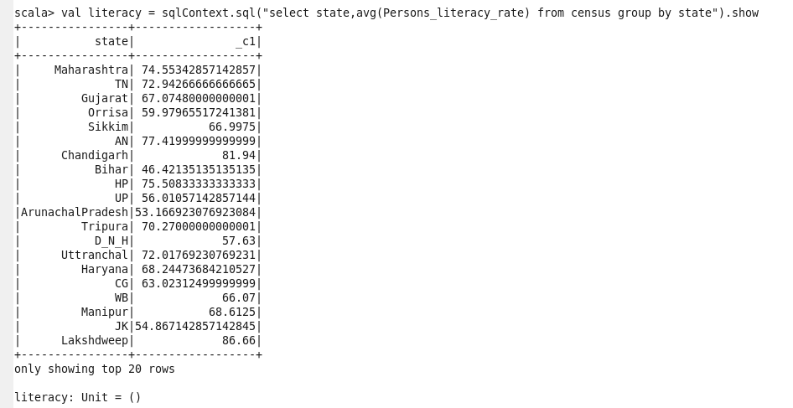

1. Find out the states with more female population:

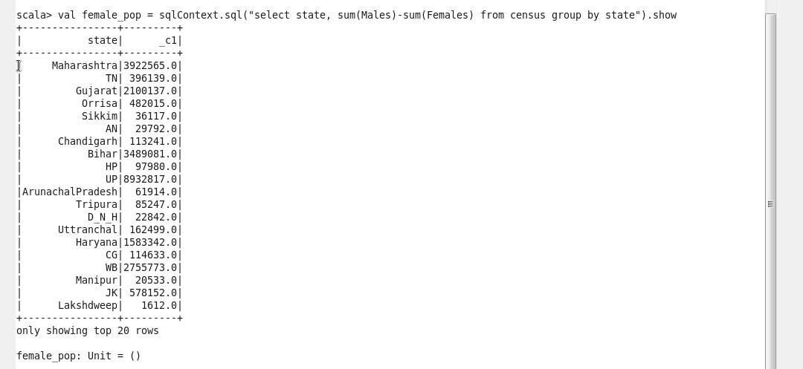

1. Find out the percentage of population in every state:

